# Good Luck: - A Career Guidance Website



## *A project report submitted to*

***Rajiv Gandhi Proudyogiki Vishwavidhyalaya, Bhopal in partial fulfillment for the award of***

***the degree of***

***Bachelor of Technology***

***In***

***Computer Science & Engineering***

**DEPARTMENT OF COMPUTER SCIENCE & ENGINEERING**

**SUSHILA DEVI BANSAL COLLEGE OF TECHNOLOGY INDORE- 453331**

**Jan-June 2024**

**Good Luck: A Career Guidance Website**



***A project report submitted to***

***Rajiv Gandhi Proudyogiki Vishwavidhyalaya, Bhopal in partial fulfillment for the award of***

***the degree of***

***Bachelor of technology***

***in***

***Computer Science & Engineering***

**PROJECT GUIDE**  **SUBMITTED BY**

Prof. MANISHA KADAM Arundhati Panwar 0829CS211038

Gouri Thakur 0829CS211062

Sonali Salve 0829CS191165

Dimpal Kumari 0829CS211052

**DEPARTMENT OF COMPUTER SCIENCE & ENGINEERING**

**SUSHILA DEVI BANSAL COLLEGE OF TECHNOLOGY**

**INDORE- 453331**

**Jan-June 2024**

**ACKNOWLEDGEMENT**

I would like to express my heartfelt gratitude to the Good Luck Career Guidance Website for being an invaluable resource in my educational journey. This platform has been a guiding light, a source of knowledge, and a companion in my pursuit of learning.

I want to extend my thanks to the dedicated team behind the Good Luck Career Guidance Website for their unwavering commitment to providing high-quality educational content. Their efforts have not only enriched my understanding but also made learning an enjoyable experience.

The vast array of subjects, courses, and materials available on the Good Luck Career Guidance Website has broadened my horizons and helped me acquire new skills. It has been a constant source of inspiration, enabling me to explore diverse fields of study and stay updated with the latest trends and developments.

I must also acknowledge the interactive and user-friendly interface of the website, which has made my learning process smooth and engaging. The accessibility and convenience of the platform have undoubtedly contributed to my academic success.

In conclusion, I am truly grateful to the Good Luck Career Guidance for its remarkable contribution to my educational growth. It has been a trusted companion throughout my academic journey, and I look forward to continuing this fruitful association. Thank you for making learning smarter, more accessible, and, most importantly, enjoyable.

**ARUNDHATI PANWAR 0829CS211038**

**GOURI THAKUR 0829CS211062**

**SONALI SALVE 0829CS191165**

**DIMPAL KUMARI 0829CS211052**

# SUSHILA DEVI BANSAL COLLEGE OF TECHNOLOGY INDORE, 453331



## CERTIFICATE

This is to certify that ARUNDHATI **PANWAR (0829CS211038), GOURI THAKUR (0829CS211062), SONALI SALVE (0829CS191165), DIMPAL KUMARI (0829CS211052)** have completed their project work, titled

**“GOOD LUCK: A CAREER GUIDANCE WEBSITE”** as per the syllabus and have submitted a satisfactory report on this project as a part of fulfillment towards thedegree of **“BACHELOR OF TECHNOLOGY” (Computer Science & Engineering)** from **RAJIV GANDHI PROUDYOGIKI VISHWAVIDHYALAYA, BHOPAL.**

**DEAN**    **HEAD OF THE DEPARTMENT**   **PROJECT GUIDE**

Dr. Rajesh Chakravarti Prof. Shraddha Kumar Prof Manisha Kadam

**DIRECTOR**

Dr P.S Chauhan

# SUSHILA DEVI BANSAL COLLEGE OF TECHNOLOGY INDORE, 453331



## CERTIFICATE

This is to certify that **ARUNDHATI PANWAR 0829CS211038, GOURI THAKUR 0829CS211062, SONALI SALVE 0829CS191165, DIMPAL KUMARI 0829CS211052** have completed their project work, titled **“GOOD LUCK: A CAREER GUIDANCE WEBSITE”** as per the syllabus and have submitted a satisfactory report on this project as a part of fulfillment towards the degree of **“BACHELOR OF TECHNOLOGY” (Computer Science & Engineering)** from **RAJIV GANDHI PROUDYOGIKI VISHWAVIDHYALAYA, BHOPAL.**

**INTERNAL EXAMINER EXTERNAL EXAMINER**

**CONTENTS**

**TITLE PAGE NO.**

**ABSTRACT i**

**LIST OF TABLES ii**

**LIST OF FIGURES iii**

**LIST OF SYMBOLS iv**

1. **Introduction**  1

* 1. Purpose of the project
  2. Scope
  3. Problem in existing system

1. **System Requirement Analysis**

* 1. Introduction

* + 1. Purpose of SRS
    2. Intended Audience and Reading Suggestions
    3. Product Scope

* 1. Overall Description

* + 1. Product Perspective
    2. Product Functions
    3. User Classes and Characteristics
    4. Operating Environment

* 1. External Interface Requirements

* + 1. User Interfaces
    2. Hardware Interfaces
    3. Software Interfaces
    4. Communications Interfaces

* 1. Functional Requirement

2.4.1 UserLogin

2.4.2 User Profiles

2.4.3 Course Management

2.4.4 Browsing Courses

2.4.5 Assessment and Grading

2.4.6 User Support

* 1. Nonfunctional Requirements

* + 1. Performance Requirements
    2. Safety Requirements
    3. Security Requirements
    4. Availability Requirements

* 1. Project Plan

* + 1. Team Members
    2. Division of Work
    3. Time Schedule

1. **Analysis**

* 1. Methodology Used
  2. Use Case Diagrams
  3. Activity Diagram
  4. Sequence Diagram
  5. E-R Diagram

1. **Design**

* 1. Architectural Design
  2. Database Design
  3. Interface Design
     1. Screenshots

1. **Implementation**

* 1. Language and database system used for the implementation
  2. Features of language and database used for the project
  3. Description of third-party tools used

1. **Testing**

* 1. White Box Testing

i. Purpose

ii. Inputs

iii. Expected Outputs & Actual Outputs

* 1. Black Box Testing
     1. Interface testing

**7.Conclusion**

1. **References**

**Abstract:**

Title: "Good Luck: A Career Guidance Website "

This project report provides an overview of "Good Luck," a career guidance website developed to assist individuals in making well-informed career decisions. "Good Luck" aims to offer a holistic approach to career guidance by providing users with the tools and information necessary to navigate their professional journeys effectively.

The report outlines the primary objectives of the project, including helping users explore diverse career paths, offering insights into educational and training opportunities, and providing resources to enhance job readiness. These objectives underpin the core mission of "Good Luck."

A detailed description of the website's features is presented, emphasizing personalized career assessments, informative articles, job market insights, and interactive tools for self-assessment and career planning. These features are designed to empower users with the knowledge they need to make informed career decisions.

The report delves into the development process, highlighting the selection of technologies and tools used in building the website. It describes the user interface design, database structure, and the development of algorithms that match users with suitable career options.

The report also highlights the impact of the "Good Luck" website on users' career decisions and aspirations. It underscores the potential of the website to positively influence individuals' career choices and offers insights into future enhancements and expansions, such as incorporating artificial intelligence for more personalized recommendations and integrating social networking features for professional networking.

In conclusion, the "Good Luck" website represents a forward-thinking initiative to provide accessible and reliable career guidance. This report serves as a comprehensive documentation of the project, emphasizing its achievements and future potential. It underscores the significance of "Good Luck" in addressing the critical need for career guidance in today's dynamic job market, empowering individuals to make confident and informed career choices.

**List of Tables:**

Table 1: Functional Requirements

Table 2: Nonfunctional Requirements

Table 3: System Features

Table 4: User Classes and Characteristics

Table 5: Language and Database System Used for Implementation

Table 6: Third-Party Tools Used

Table 7: White Box Testing - Test Case Details

Table 8: Black Box Testing - Test Case Details

Table 9: References

**List of Figures:**

Figure 1: System Architecture Diagram

Figure 2: Use Case Diagram

Figure 3: Activity Diagram

Figure 4: Sequence Diagram

Figure 5: E-R Diagram

Figure 6: User Interface - Homepage

Figure 7: User Interface – Career Suggestions

Figure 8: User Interface – Login page

Figure 9: User Interface – FAQ’s

List of Symbols:

N/A

Software Requirements Specification (SRS) Report

### 1. Introduction

#### 1.1 Purpose of the Project

The purpose of the "Good Luck" website is to serve as an innovative and user-centric online platform that offers comprehensive career guidance and resources to help individuals make informed and confident decisions about their careers. This website is designed to empower users by providing them with personalized career assessments, informative articles, job market insights, and interactive tools for self-assessment and career planning. It aims to fill the crucial need for accessible and reliable career guidance in today's dynamic job market, assisting users in navigating their professional journeys with greater clarity and assurance.

#### 1.2 Scope

**The scope of the "Good Luck" website includes personalized career assessments, informative articles, job market insights, self-assessment tools, user feedback and interaction, and potential future enhancements like AI integration and professional networking features. It aims to be user-friendly and accessible, providing a comprehensive resource for individuals seeking career guidance.**

#### 1.3 Problem in the Existing System

The problems in the existing system include fragmented resources, generic advice, lack of interactivity, limited job market insights, minimal user engagement, and outdated technology. These issues hinder users in making well-informed career choices, necessitating the development of the "Good Luck" website.

## 2.System Requirement Analysis

### 2.1 Introduction

#### 2.1.1 Purpose of SRS

The purpose of the "Good Luck" Career Guidance Website in the SRS is to empower users by offering personalized career guidance, informative resources, and interactive tools, facilitating informed career decisions, while also allowing for potential future enhancements.

#### 2.1.2 Intended Audience and Reading Suggestions

This document targets the development team, project stakeholders, and project managers. A thorough review is recommended to understand project requirements.

#### 2.1.3 Product Scope

The product scope of "Good Luck" includes personalized career assessments, informative content, job market insights, interactive self-assessment tools, user engagement features, and potential AI integration and professional networking enhancements. The website's focus is on providing comprehensive and user-friendly career guidance, helping individuals make informed decisions about their professional journeys.

#### 2.1 Overall Description

##### 2.2.1 Product Perspective

##### "Good Luck" is positioned as a user-centric career guidance platform within the context of online resources.

##### 2.2.2 Product Functions

The main function of our website is to facilitate student interaction, allowing them to input their chosen subjects and receive valuable knowledge and advice regarding related courses and colleges to aid in their career decision-making process.

##### 2.2.3 User Classes and Characteristics

Users are categorized into students, instructors, and administrators, each with defined roles.

##### 2.2.4 Operating Environment

Good Luck Career Guidance website operates in a web-based environment, accessible via various browsers and devices.

#### 2.3 External Interface Requirements

**2.3.1 User Interfaces**

User-friendly interfaces facilitate easy navigation and learning.

**2.3.2 Hardware Interfaces**

Standard hardware components (servers, storage, network infrastructure) are required.

**2.3.3 Software Interfaces**

Integration with MySQL for database management and external APIs for data exchange.

**2.3.4 Communications Interfaces**

Secure communication protocols ensure safe data exchange between users and the server.

**2.4 Functional Requirements**

**2.4.1 User Login:**

* Users should be able to create accounts by providing necessary information. 
* The system must securely verify and authenticate user credentials.

**2.4.2 User Profiles:**

* Users can create and update their profiles with personal details.
* Profiles should display user-specific information like recommended courses Self-Assessment.

**2.4.3 Course Management:**

* Instructors should create and manage courses, adding materials, assessments, and multimedia content.

**2.4.4 Browsing Courses:**

* Users should browse and search courses using filters, categories, and a search function.

**2.4.5 Assessment and Grading:**

* Instructors can create assessments, quizzes, and assignments. The system should provide automated grading and user feedback.

**2.4.6 User Support:**

* Users should access support resources like FAQs and help documentation.

#### 2.5 Nonfunctional Requirements

**2.5.1 Performance Requirements:**

* The system must provide a responsive user experience with fast page loading times.

**2.5.2 Safety Requirements:**

* Data privacy and user information security must be upheld throughout the system.

**2.5.3 Security Requirements:** • Robust security measures should protect against unauthorized access and data breaches.

**2.5.4 Availability Requirements:**

* The website must be available 24/7 with minimal downtime for maintenance.

**2.6 Project Plan**

#### 2.6.1 Team Members

The project will be executed by a dedicated team, including developers, designers, and project managers.

1. ARUNDHATI PANWAR (0829CS211038)
2. GOURI THAKUR (0829CS211062)
3. SONALI SALVE (0829CS191165)
4. DIMPAL KUMARI (0829CS211052)

#### 2.6.2 Division of Work

Roles and responsibilities will be assigned to team members based on their expertise.

1. Arundhati Panwar – Frontend developer and Documentation
2. Gouri Thakur – Frontend developer
3. Sonali Salve – Database developer
4. Dimpal Kumari – Frontend

**2.6.3 Time Schedule**

A Gantt chart will outline the project's timeline, depicting key milestones and deliverables.

| ----------------------------------------------------------- | | | | | | | | | | | | | | | | | | | | | | | | | | | | | | | | | | | |
| --- | --- | --- | --- | --- | --- | --- | --- | --- | --- | --- | --- | --- | --- | --- | --- | --- | --- | --- | --- | --- | --- | --- | --- | --- | --- | --- | --- | --- | --- | --- | --- | --- | --- | --- | --- |
|  | Task | | | | | | | | | | | | | | | | | | | | | | | | | | | | | Duration | | | | | | | |
| ---------------------------------------------------------- | | | | | | | | | | | | | | | | | | | | | | | | | | | | | | | | | | | |
|  | Project Initiation | | | | | | | | | | | | | | | | | | | | | | | | | | | | | 1  2 |  | week | | | | |  |
|  | Requirements Gathering | | | | | | | | | | | | | | | | | | | | | | | | | | | | |  | weeks | | | | |
|  | System | | | | Design | | | | | | | | | | | | | | | | | | | | | | | | | 3 | weeks | | | | |
|  | Front | | | -End | | | Development | | | | | | | | | | | | | | | | | | | | | | | 4 | weeks | | | | |
|  | Back | | -End | | | Development | | | | | | | | | | | | | | | | | | | | | | | | 4 | weeks | | | | |
|  | Database Design | | | | | | | | | | | and | | | Integration | | | | | | | | | | | | | | | 3 | weeks | | | | |
|  |  | User | Authentication | | | | | | | | | | | | | System | | | | |  | | | | | | | | | 2 | weeks | | | | |
|  | Course Management | | | | | | | | | | | |  | System | | | | |  | | | | | | | | | | | 3 | weeks | | | | |
|  | Content Management | | | | | | | | | | | | | | System | | | | |  | | | | | | | | |  | 3 | weeks | | | | |  |
|  |  | User | Profile | | | | | | | and | | Enrollment | | | | | | | | | | System | | |  | | | | |  | 2 | weeks | | | | |
|  | Assessment | | | | | | | | and | | Grading | | | | | | | System | | | | |  | | | | | | | 2 | weeks | | | | |
|  |  | User | Communication | | | | | | | | | | | | and | | Support | | | | | | | System | |  | | | | 2 | weeks | | | | |
|  | Testing | | | | | and | | | Quality Assurance | | | | | | | | | | | | | | | | | | | | | |  | 4 | weeks | | | | |
|  |  | User | Acceptance Testing | | | | | | | | | | | | | | | | | | | | | | | | | | | | 2 | weeks | | | | |
|  | Bug Fixes | | | | | | | and | | Refinements | | | | | | | | | | | | | | | | | | | | | 2 | weeks | | | | |
|  | Documentation | | | | | | | | | | and | |  | User | | | Training | | | | | | | | | | | | | | 2 | weeks | | | | |
|  | Deployment | | | | | | | | and | | Launch | | | | | | | | | | | | | | | | | | | |  |  | 1 week | | | |
| ---------------------------------------------------------- | | | | | | | | | | | | | | | | | | | | | | | | | | | | | | | | | | | |
|  | Total Duration | | | | | | | | | | | | | | | | | | | | | | | | | | | | |  | 42 |  | weeks | | | |  |
| ----------------------------------------------------------- | | | | | | | | | | | | | | | | | | | | | | | | | | | | | | | | | | | |

|

**3. Analysis Model**

**3.1 Methodology Used**

The project will follow an Object-Oriented methodology for system development.

#### 3.2 Use Case Diagrams

Use case diagrams will be used to illustrate system interactions and user roles.

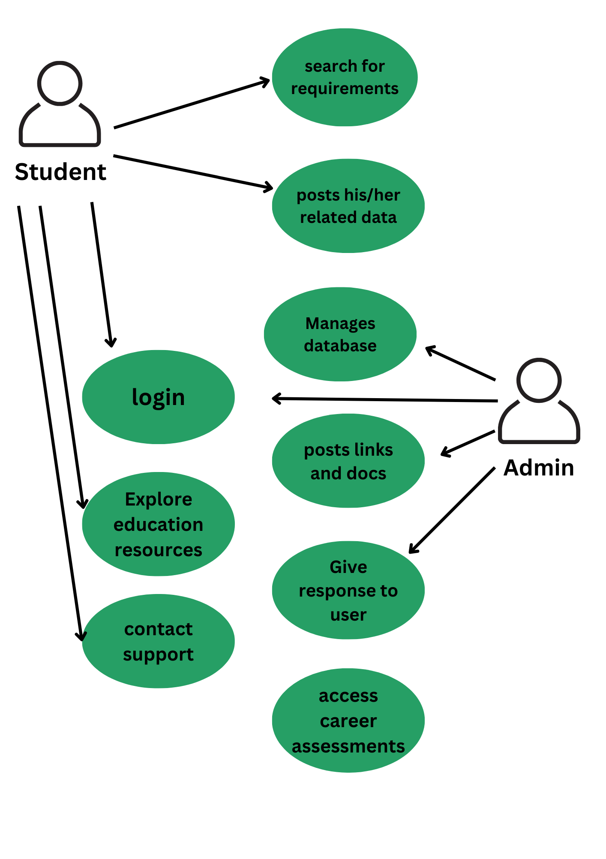

#### 3.3 Activity Diagram

Activity diagrams will represent the flow of activities within the system.

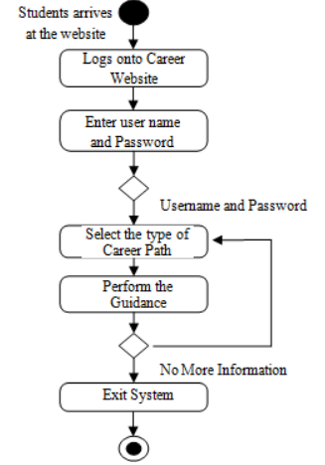

**3.4 Sequence Diagram**

Sequence diagrams will show the sequence of interactions between system components.

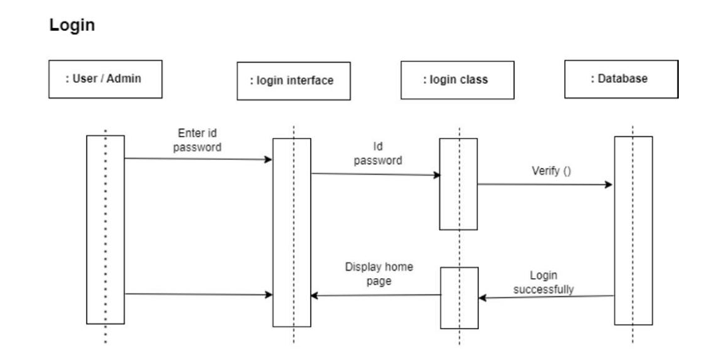

#### 3.5 E-R Diagram

E-R diagram visually represents the relationships between entities in a database.

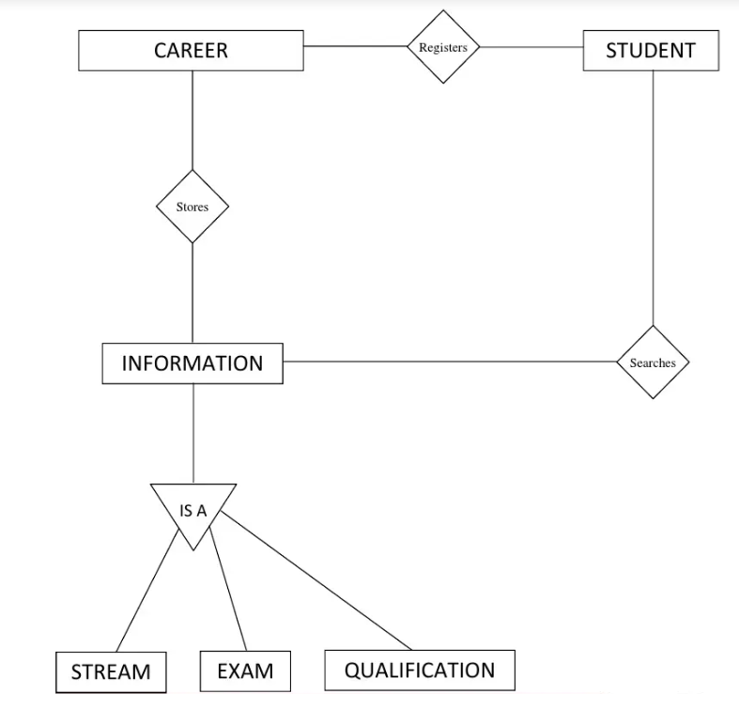

### 4. Design Model

#### 4.1 Architectural Design

The system architecture will be visually represented with an architecture diagram and described in detail.

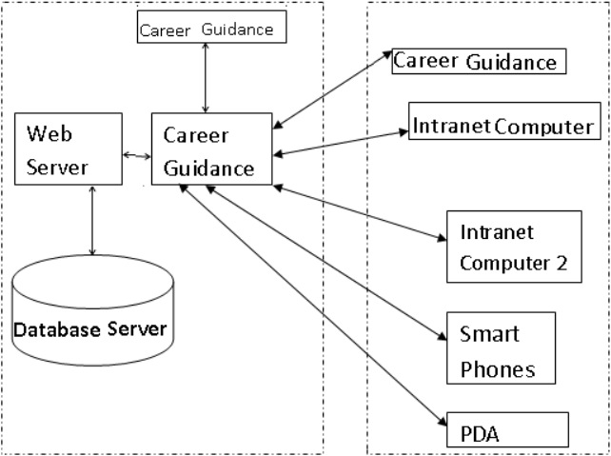

#### 4.2 Database Design

Normalization techniques will be applied to the database for efficient data storage.

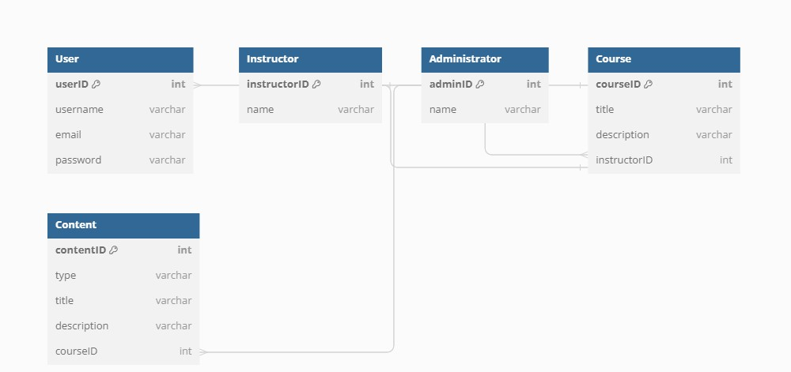

#### 4.3 Interface Design

Screenshots of the user interface will be provided to visualize the website's design

Figure 1: User Interface - Homepage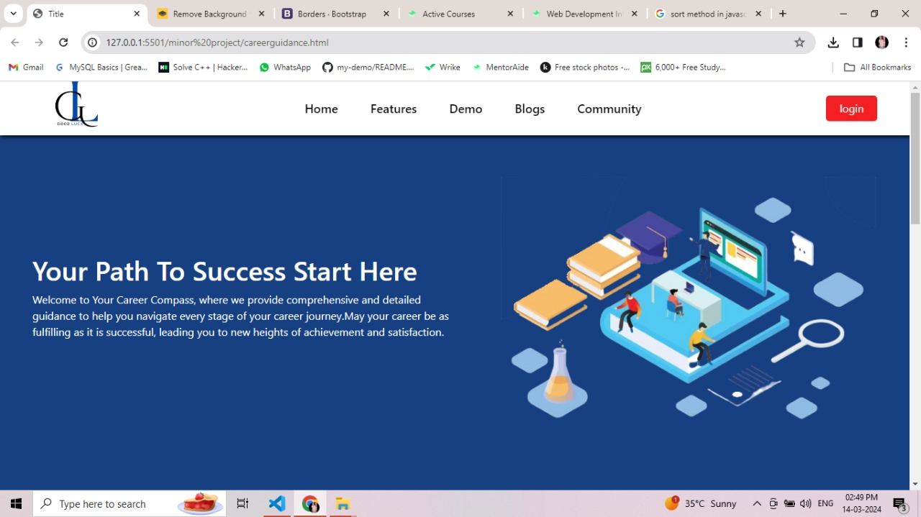

Figure 2: User Interface – Career Suggestions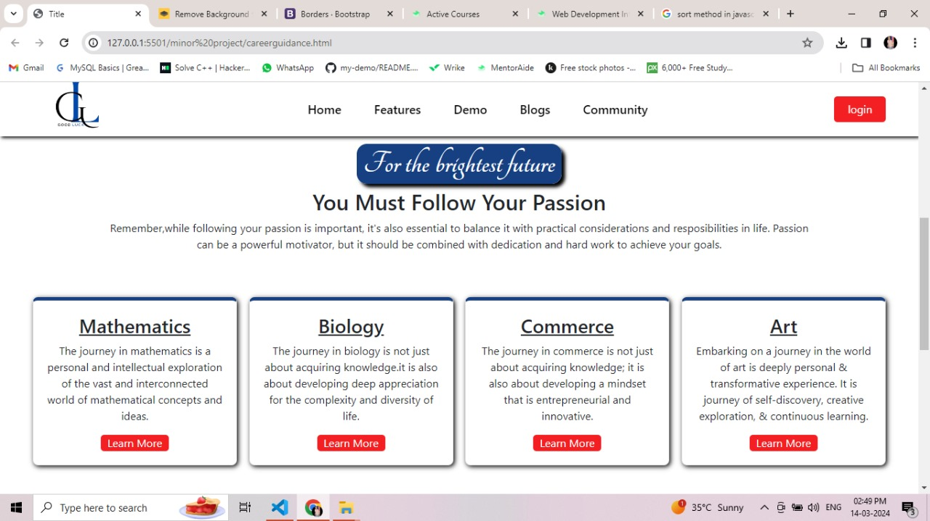

Figure 3: User Interface –Login Page

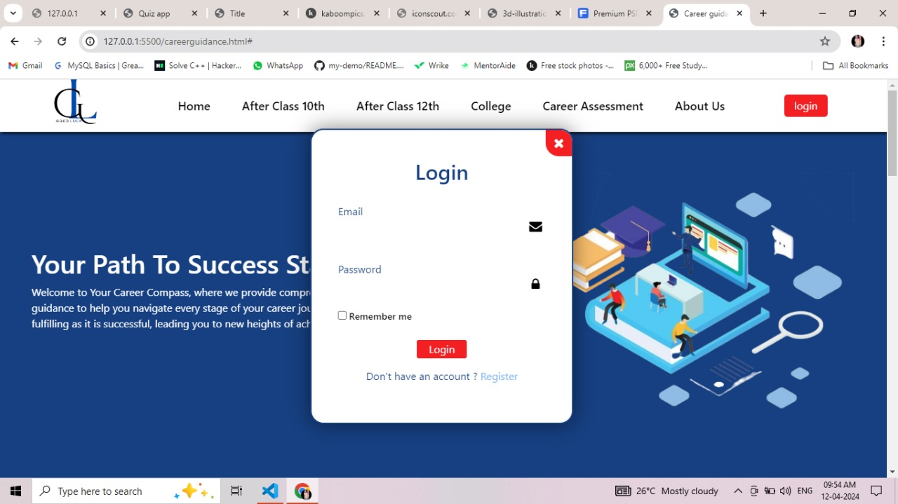

Figure 4: User Interface – FAQ’s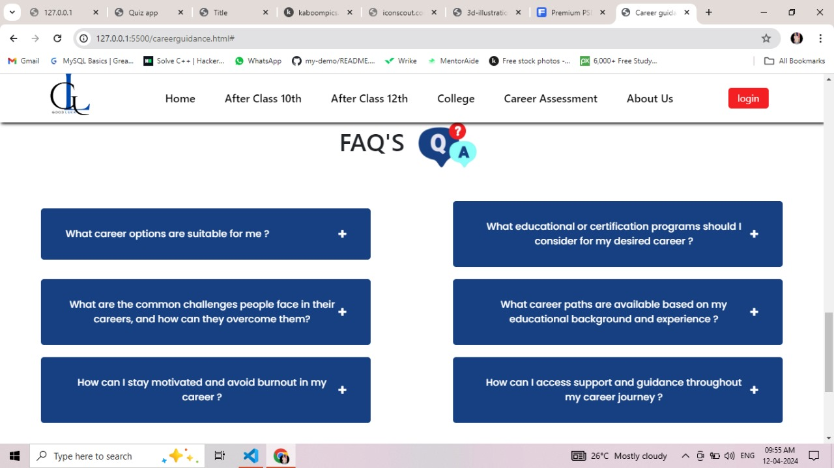

**5**. **Implementation**

#### 5.1 Language and Database System Used for the Implementation

Good Luck Career Guidance will be implemented using the following technologies:

| • | **Languages:** | HTML, CSS, JavaScript | |
| --- | --- | --- | --- |
| • | **Database System:** | | MySQL, PHP |

##### 5.2 Features of the Language and database system used for Project

The chosen languages and database system offer versatility, performance, and scalability required for the project's development and operation.

#### 5.3 Description of Third-Party Tools Used (If Any) in the project

Details regarding third-party tools integrated into the project will be provided, including their purpose and how they enhance the platform.

**6.Testing Techniques**

#### 6.1 White Box Testing (Basis Path Testing)

White box testing, specifically basis path testing, will be employed to ensure the structural correctness and reliability of the codebase.

(i) Purpose

Ensure every logical path in the code is tested to:

* Identify and correct logical errors • Increase code coverage
* Validate internal logic robustness

1. Inputs

Include boundary values, valid/invalid inputs, special cases, and combinatorial inputs to cover all execution paths.

1. Expected vs. Actual Outputs

Compare expected (anticipated based on inputs and logic) with actual outputs to pinpoint defects and improve code quality.

#### 6.2 Black Box Testing

Various forms of black box testing, such as interface testing, will be conducted to validate the functional behavior and usability of the system.

### 7.Conclusion

In conclusion, this Software Requirements Specification (SRS) report outlines the requirements, analysis, design, implementation details, and testing techniques for the Good Luck Career Guidance Website. By fostering a user-friendly and informative platform, we aspire to guide students towards successful educational and professional paths, equipping them with the knowledge needed for a brighter future.

#### 8.References

(OpenAI, n.d.) or (OpenAI, 2022) if you want to refer to the year of publication or the last update.

(Google Inc., n.d.) or (Google Inc., 2022) if you want to refer to the year of publication or the last update.

References:

For ChatGPT:

OpenAI. (n.d.). GPT-3.5 Architecture. https://openai.com/research/gpt-3.5 For Google:

Google Inc. (n.d.). Google: About Us. https://about.google